Abstract Title use «Abstract_title» pre-defined style in the «Styles Pane»

Anna Karenina¹, Jean-Luc Piccard¹, Jean Cauvin^{1,2}, Emma Bovary² Use the «Abstract_Author» pre-defined style in the «Styles Pane»

¹ Department of Environmental Sciences, University of Basel, Bernoullistrasse 32, CH-4056 Basel (albert.einstein@unibas.ch)
² Geologisch Institut, University of Vienna, Innrain 52, A-6020 Innsbruck use the «Abstract_address» pre-defined style in the «Styles Pane»

Suspendisse eros lorem, condimentum vitae, mollis in, iaculis et, neque. Fusce pulvinar risus eget dolor. Vestibulum ante ipsum primis in faucibus orci luctus et ultrices posuere cubilia Curae; Fusce bibendum nisl. Ut vitae quam in ipsum ultricies sollicitudin. Suspendisse quis eros... Use the «Abstract_body_text» pre-defined style in the «Styles Pane»

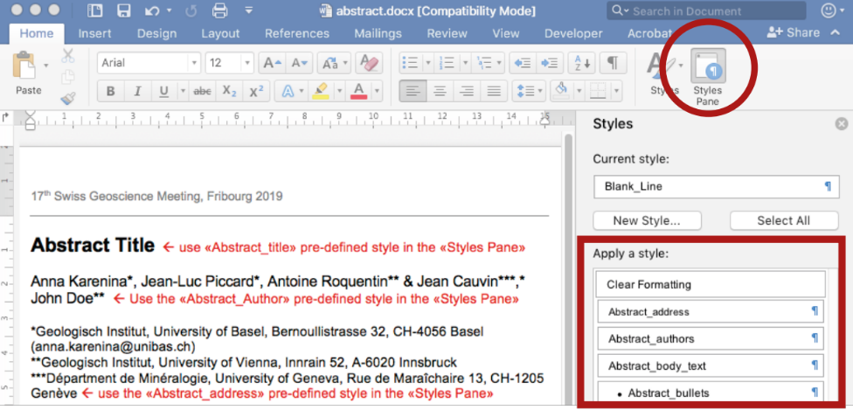

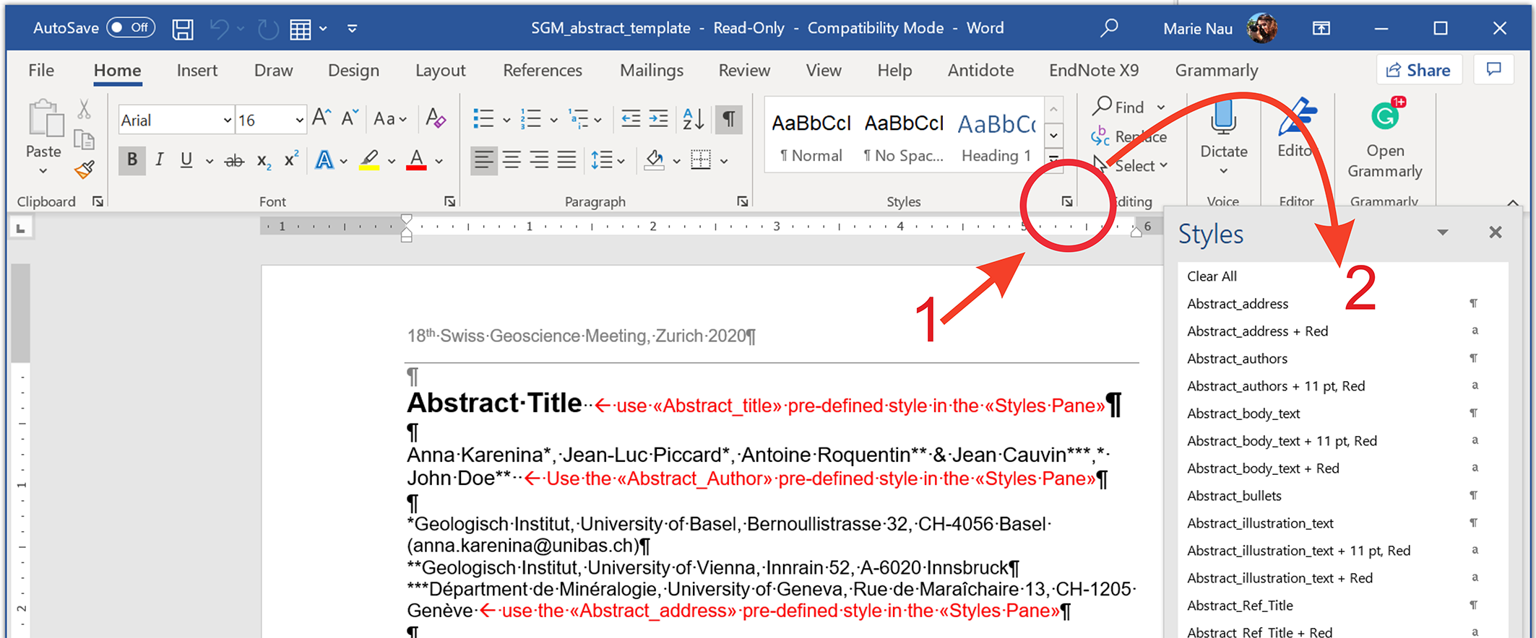

Figure 1. How to find the «Style Pane» in Word on Mac (top) and Windows (bottom). The red rectangle shows an exerpt of the styles to be used for your abstract (and which are embedded in this template). Use the «Abstract_illustration_text» pre-defined style in the «Styles Pane»

REFERENCES use the «abstract_ref_Title» style
Lanphere, M., & Pamic J. 1992: Fluid inclusions in speleothems, Acta Geologica, 22, 5-22. use the «Abstract_References» pre_defined style

